**Introduction to Java**

**What is Java?**

Java is a **programming language** and a **platform**. Java is a high level, robust, object-oriented and secure programming language.

Java was developed by *Sun Microsystems* (which is now the subsidiary of Oracle) in the year 1995. *James Gosling* is known as the father of Java. Before Java, its name was *Oak*. Since Oak was already a registered company, so James Gosling and his team changed the name from Oak to Java.

**Platform**: Any hardware or software environment in which a program runs, is known as a platform. Since Java has a runtime environment (JRE) and API, it is called a platform.

**Java Example**

Let's have a quick look at Java programming example. A detailed description of Hello Java example is available in next page.

**Simple.java**

class Simple{

    public static void main(String args[]){

     System.out.println("Hello Java");

    }

}

**Application**

According to Sun, 3 billion devices run Java. There are many devices where Java is currently used. Some of them are as follows:

1. Desktop Applications such as acrobat reader, media player, antivirus, etc.
2. Web Applications such as irctc.co.in, javatpoint.com, etc.
3. Enterprise Applications such as banking applications.
4. Mobile
5. Embedded System
6. Smart Card
7. Robotics
8. Games, etc.

**Types of Java Applications**

There are mainly 4 types of applications that can be created using Java programming:

**1) Standalone Application**

Standalone applications are also known as desktop applications or window-based applications. These are traditional software that we need to install on every machine. Examples of standalone application are Media player, antivirus, etc. AWT and Swing are used in Java for creating standalone applications.

**2) Web Application**

An application that runs on the server side and creates a dynamic page is called a web application. Currently, [Servlet](https://www.javatpoint.com/servlet-tutorial), [JSP](https://www.javatpoint.com/jsp-tutorial), [Struts](https://www.javatpoint.com/struts-2-tutorial), [Spring](https://www.javatpoint.com/spring-tutorial), [Hibernate](https://www.javatpoint.com/hibernate-tutorial), [JSF](https://www.javatpoint.com/jsf-tutorial), etc. technologies are used for creating web applications in Java.

**3) Enterprise Application**

An application that is distributed in nature, such as banking applications, etc. is called an enterprise application. It has advantages like high-level security, load balancing, and clustering. In Java, [EJB](https://www.javatpoint.com/ejb-tutorial) is used for creating enterprise applications.

**4) Mobile Application**

An application which is created for mobile devices is called a mobile application. Currently, Android and Java ME are used for creating mobile applications.

**Java Platforms / Editions**

There are 4 platforms or editions of Java:

**1) Java SE (Java Standard Edition)**

It is a Java programming platform. It includes Java programming APIs such as java.lang, java.io, java.net, java.util, java.sql, java.math etc. It includes core topics like OOPs, [String](https://www.javatpoint.com/java-string), Regex, Exception, Inner classes, Multithreading, I/O Stream, Networking, AWT, Swing, Reflection, Collection, etc.

**2) Java EE (Java Enterprise Edition)**

It is an enterprise platform that is mainly used to develop web and enterprise applications. It is built on top of the Java SE platform. It includes topics like Servlet, JSP, Web Services, EJB, [JPA](https://www.javatpoint.com/jpa-tutorial), etc.

**3) Java ME (Java Micro Edition)**

It is a micro platform that is dedicated to mobile applications.

**4) JavaFX**

It is used to develop rich internet applications. It uses a lightweight user interface API.

---------------------------------------------------------------------------------------------------------------------

# **History of Java**

The history of Java is very interesting. Java was originally designed for interactive television, but it was too advanced technology for the digital cable television industry at the time. The history of Java starts with the Green Team. Java team members (also known as Green Team), initiated this project to develop a language for digital devices such as set-top boxes, televisions, etc. However, it was best suited for internet programming. Later, Java technology was incorporated by Netscape.

The principles for creating Java programming were "Simple, Robust, Portable, Platform-independent, Secured, High Performance, Multithreaded, Architecture Neutral, Object-Oriented, Interpreted, and Dynamic". [Java](https://www.javatpoint.com/java-tutorial) was developed by James Gosling, who is known as the father of Java, in 1995. James Gosling and his team members started the project in the early '90s.



Currently, Java is used in internet programming, mobile devices, games, e-business solutions, etc. Following are given significant points that describe the history of Java.

1) [**James Gosling**](https://www.javatpoint.com/james-gosling-father-of-java)**, Mike Sheridan**, and **Patrick Naughton** initiated the Java language project in June 1991. The small team of sun engineers called **Green Team**.

2) Initially it was designed for small, [embedded systems](https://www.javatpoint.com/embedded-system-tutorial) in electronic appliances like set-top boxes.

3) Firstly, it was called **"Greentalk"** by James Gosling, and the file extension was .gt.

4) After that, it was called **Oak** and was developed as a part of the Green project.

5) In 1995, Oak was renamed as **"Java"** because it was already a trademark by Oak Technologies.

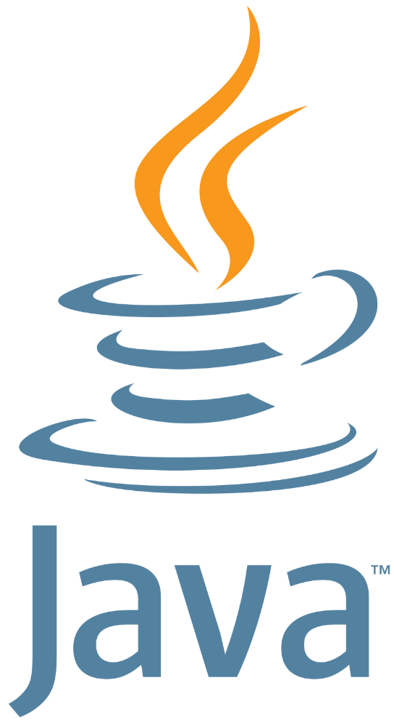

## Why Java Programming named "Java"?

6) Why had they chosen the name Java for Java language? The team gathered to choose a new name. The suggested words were "dynamic", "revolutionary", "Silk", "jolt", "DNA", etc. They wanted something that reflected the essence of the technology: revolutionary, dynamic, lively, cool, unique, and easy to spell, and fun to say.

According to James Gosling, "Java was one of the top choices along with **Silk**". Since Java was so unique, most of the team members preferred Java than other names.

7) Java is an island in Indonesia where the first coffee was produced (called Java coffee). It is a kind of espresso bean. Java name was chosen by James Gosling while having a cup of coffee nearby his office.

8) Notice that Java is just a name, not an acronym.

9) Initially developed by James Gosling at [Sun Microsystems](https://www.javatpoint.com/sun-microsystems) (which is now a subsidiary of Oracle Corporation) and released in 1995.

10) In 1995, Time magazine called **Java one of the Ten Best Products of 1995**.

11) JDK 1.0 was released on January 23, 1996. After the first release of Java, there have been many additional features added to the language. Now Java is being used in Windows applications, Web applications, enterprise applications, mobile applications, cards, etc. Each new version adds new features in Java.

---------------------------------------------------------------------------------------------------------------------

### **Java Version History**

Many java versions have been released till now. The current stable release of Java is Java SE 10.

1. JDK Alpha and Beta (1995)
2. JDK 1.0 (23rd Jan 1996)
3. JDK 1.1 (19th Feb 1997)
4. J2SE 1.2 (8th Dec 1998)
5. J2SE 1.3 (8th May 2000)
6. J2SE 1.4 (6th Feb 2002)
7. J2SE 5.0 (30th Sep 2004)
8. Java SE 6 (11th Dec 2006)
9. Java SE 7 (28th July 2011)
10. Java SE 8 (18th Mar 2014)
11. Java SE 9 (21st Sep 2017)
12. Java SE 10 (20th Mar 2018)
13. Java SE 11 (September 2018)
14. Java SE 12 (March 2019)
15. Java SE 13 (September 2019)
16. Java SE 14 (Mar 2020)
17. Java SE 15 (September 2020)
18. Java SE 16 (Mar 2021)
19. Java SE 17 (September 2021) LTS Release
20. Java SE 18 (March 2022)
21. Java SE 19 (September 2022)
22. Java SE 20 (March 2023)

Since Java SE 8 release, the Oracle corporation follows a pattern in which every even version is release in March month and an odd version released in September month.

# **Features of Java**

The primary objective of [Java programming](https://www.javatpoint.com/java-tutorial) language creation was to make it portable, simple and secure programming language. Apart from this, there are also some excellent features which play an important role in the popularity of this language. The features of Java are also known as Java buzzwords.

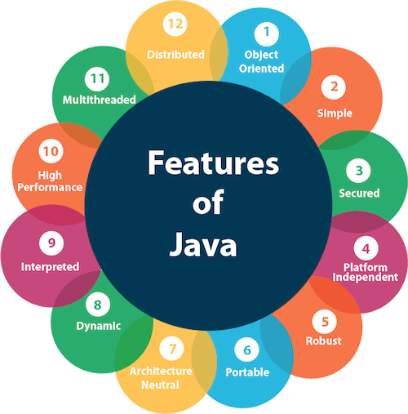

1. [Simple](https://www.javatpoint.com/features-of-java#Simple)
2. [Object-Oriented](https://www.javatpoint.com/features-of-java#Object-Oriented)
3. [Portable](https://www.javatpoint.com/features-of-java#Portable)
4. [Platform independent](https://www.javatpoint.com/features-of-java#Platform-independent)
5. [Secured](https://www.javatpoint.com/features-of-java#Secured)
6. [Robust](https://www.javatpoint.com/features-of-java#Robust)
7. [Architecture neutral](https://www.javatpoint.com/features-of-java#Architecture-neutral)
8. [Interpreted](https://www.javatpoint.com/features-of-java#Interpreted)
9. [High Performance](https://www.javatpoint.com/features-of-java#High-Performance)
10. [Multithreaded](https://www.javatpoint.com/features-of-java#Multithreaded)
11. [Distributed](https://www.javatpoint.com/features-of-java#Distributed)
12. [Dynamic](https://www.javatpoint.com/features-of-java#Dynamic)

### Simple

Java is very easy to learn, and its syntax is simple, clean and easy to understand. According to Sun Microsystem, Java language is a simple programming language because:

* Java syntax is based on C++ (so easier for programmers to learn it after C++).
* Java has removed many complicated and rarely-used features, for example, explicit pointers, operator overloading, etc.
* There is no need to remove unreferenced objects because there is an Automatic Garbage Collection in Java.

### Object-oriented

Java is an [object-oriented](https://www.javatpoint.com/java-oops-concepts) programming language. Everything in Java is an object. Object-oriented means we organize our software as a combination of different types of objects that incorporate both data and behavior.

Object-oriented programming (OOPs) is a methodology that simplifies software development and maintenance by providing some rules.

Basic concepts of OOPs are:

1. [Object](https://www.javatpoint.com/object-and-class-in-java)
2. [Class](https://www.javatpoint.com/object-and-class-in-java#class)
3. [Inheritance](https://www.javatpoint.com/inheritance-in-java)
4. [Polymorphism](https://www.javatpoint.com/runtime-polymorphism-in-java)
5. [Abstraction](https://www.javatpoint.com/abstract-class-in-java)
6. [Encapsulation](https://www.javatpoint.com/encapsulation)

### Platform Independent

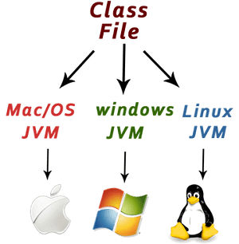

Java is platform independent because it is different from other languages like [C](https://www.javatpoint.com/c-programming-language-tutorial), [C++](https://www.javatpoint.com/cpp-tutorial), etc. which are compiled into platform specific machines while Java is a write once, run anywhere language. A platform is the hardware or software environment in which a program runs.

There are two types of platforms software-based and hardware-based. Java provides a software-based platform.

The Java platform differs from most other platforms in the sense that it is a software-based platform that runs on top of other hardware-based platforms. It has two components:

1. Runtime Environment
2. API (Application Programming Interface)

Java code can be executed on multiple platforms, for example, Windows, Linux, Sun Solaris, Mac/OS, etc. Java code is compiled by the compiler and converted into bytecode. This bytecode is a platform-independent code because it can be run on multiple platforms, i.e., Write Once and Run Anywhere (WORA).

### Secured

Java is best known for its security. With Java, we can develop virus-free systems. Java is secured because:

* **No explicit pointer**
* **Java Programs run inside a virtual machine sandbox**

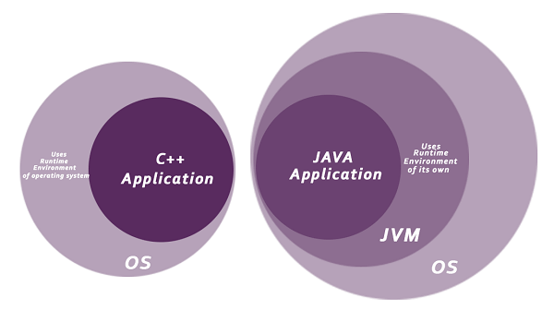

* **Classloader:** Classloader in Java is a part of the Java Runtime Environment (JRE) which is used to load Java classes into the Java Virtual Machine dynamically. It adds security by separating the package for the classes of the local file system from those that are imported from network sources.
* **Bytecode Verifier:** It checks the code fragments for illegal code that can violate access rights to objects.
* **Security Manager:** It determines what resources a class can access such as reading and writing to the local disk.

Java language provides these securities by default. Some security can also be provided by an application developer explicitly through SSL, JAAS, Cryptography, etc.

### Robust

The English mining of Robust is strong. Java is robust because:

* It uses strong memory management.
* There is a lack of pointers that avoids security problems.
* Java provides automatic garbage collection which runs on the Java Virtual Machine to get rid of objects which are not being used by a Java application anymore.
* There are exception handling and the type checking mechanism in Java. All these points make Java robust.

### Architecture-neutral

Java is architecture neutral because there are no implementation dependent features, for example, the size of primitive types is fixed.

In C programming, int data type occupies 2 bytes of memory for 32-bit architecture and 4 bytes of memory for 64-bit architecture. However, it occupies 4 bytes of memory for both 32 and 64-bit architectures in Java.

### Portable

Java is portable because it facilitates you to carry the Java bytecode to any platform. It doesn't require any implementation.

### High-performance

Java is faster than other traditional interpreted programming languages because Java bytecode is "close" to native code. It is still a little bit slower than a compiled language (e.g., C++). Java is an interpreted language that is why it is slower than compiled languages, e.g., C, C++, etc.

### Distributed

Java is distributed because it facilitates users to create distributed applications in Java. RMI and EJB are used for creating distributed applications. This feature of Java makes us able to access files by calling the methods from any machine on the internet.

### Multi-threaded

A thread is like a separate program, executing concurrently. We can write Java programs that deal with many tasks at once by defining multiple threads. The main advantage of multi-threading is that it doesn't occupy memory for each thread. It shares a common memory area. Threads are important for multi-media, Web applications, etc.

### Dynamic

Java is a dynamic language. It supports the dynamic loading of classes. It means classes are loaded on demand. It also supports functions from its native languages, i.e., C and C++.

Java supports dynamic compilation and automatic memory management (garbage collection).

---------------------------------------------------------------------------------------------------------------------

# **Java JDK, JRE and JVM**

## What is JVM?

JVM (Java Virtual Machine) is an abstract machine that enables your computer to run a Java program.

When you run the Java program, Java compiler first compiles your Java code to bytecode. Then, the JVM translates bytecode into native machine code (set of instructions that a computer's CPU executes directly).

Java is a platform-independent language. It's because when you write Java code, it's ultimately written for JVM but not your physical machine (computer). Since JVM ​executes the Java bytecode which is platform-independent, Java is platform-independent.

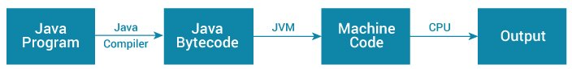Working of Java Program

If you are interested in learning about JVM Architecture, visit [The JVM Architecture Explained](https://dzone.com/articles/jvm-architecture-explained).

## What is JRE?

JRE (Java Runtime Environment) is a software package that provides Java class libraries, Java Virtual Machine (JVM), and other components that are required to run Java applications.

JRE is the superset of JVM.

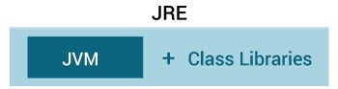

Java Runtime Environment

If you need to run Java programs, but not develop them, JRE is what you need. You can download JRE from [Java SE Runtime Environment 8 Downloads](http://www.oracle.com/technetwork/java/javase/downloads/jre8-downloads-2133155.html) page.

## What is JDK?

JDK (Java Development Kit) is a software development kit required to develop applications in Java. When you download JDK, JRE is also downloaded with it.

In addition to JRE, JDK also contains a number of development tools (compilers, JavaDoc, Java Debugger, etc).



Java Development Kit

## Relationship between JVM, JRE, and JDK.

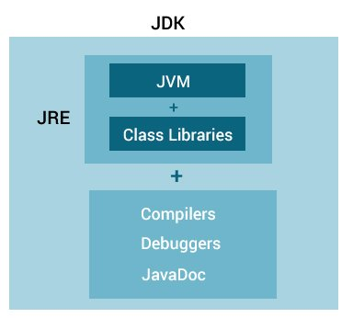

Relationship between JVM, JRE, and JDK